1. select ename, empno, deptno

from emp

where ename = 'blake';

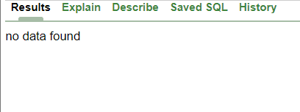

1. select ename, empno, deptno

from emp

where LOWER(ename) = 'blake';



1. select ename, CONCAT (ename, job), LENGTH (ename),

instr (ename, 'A')

from emp

where substr (job, 1, 5) = 'SALES';

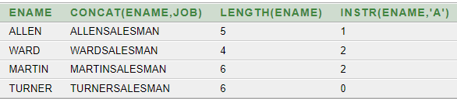

1. select ename, sal, comm, MOD(sal, comm)

from emp

where job = 'SALESMAN';

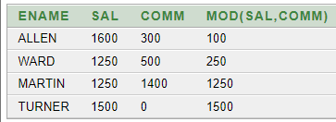

1. select ename, (SYSDATE-hiredate)/7 WEEKS

from emp

where deptno = 10;

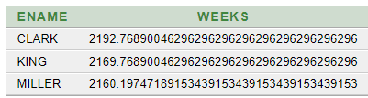

1. select ename,

TO_CHAR (hiredate, 'fmDD Month YYYY') HIREDATE

from emp;

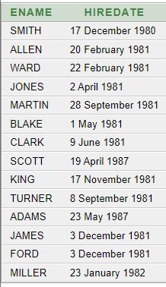

1. select TO_CHAR (sal, '$99,999') salary

from emp

where ename = 'SCOTT';



1. select ename, sal, comm, (sal*12)+NVL(comm, 0)

from emp;

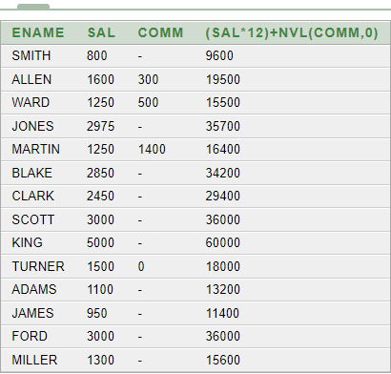

1. select job, sal,

DECODE (job, 'ANALYST', SAL*1.1,

'CLERK', SAL*1.15,

'MANAGER', SAL*1.2,

SAL)

REVISED_SALARY

from emp;

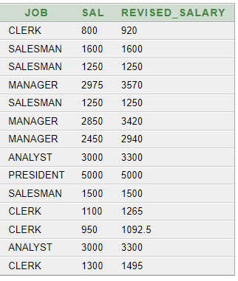

1. select ename,

NVL (TO_CHAR(mgr), 'No Manager')

from emp

where mgr is NULL;

